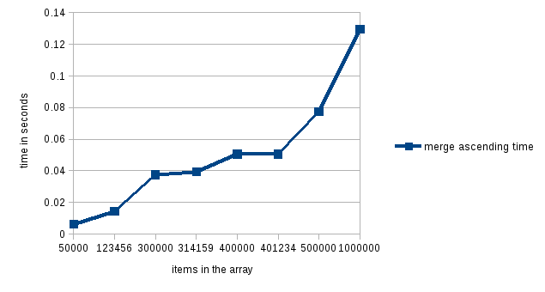
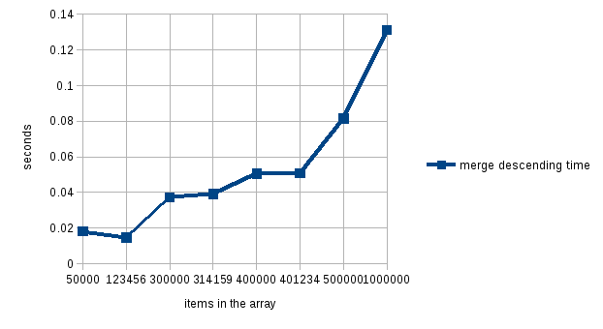
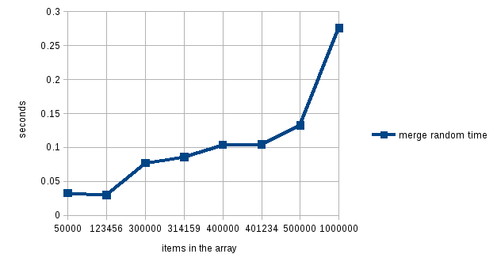

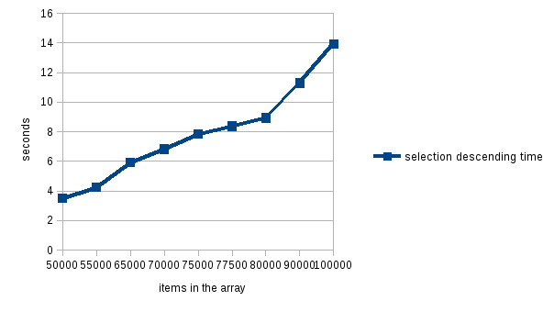
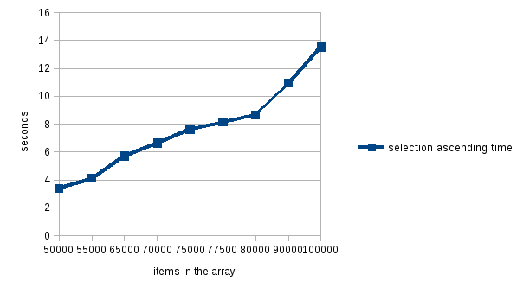
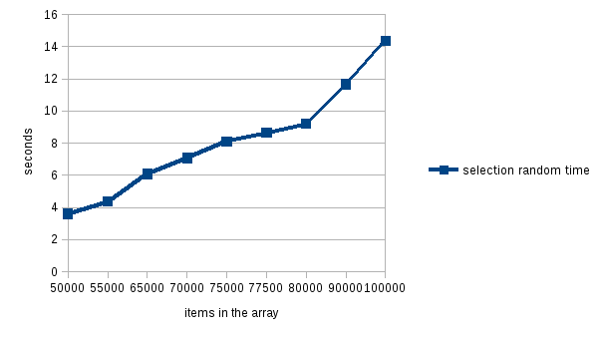

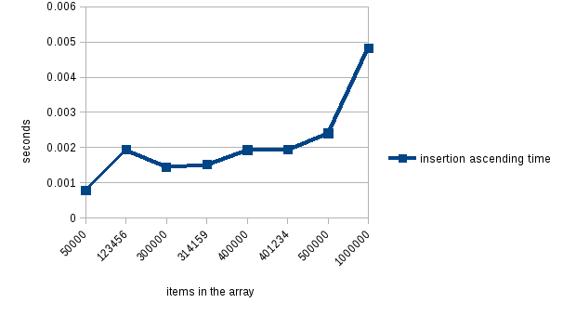
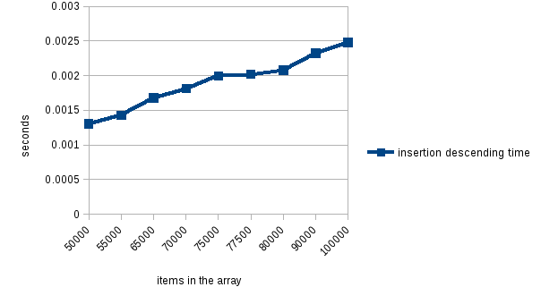
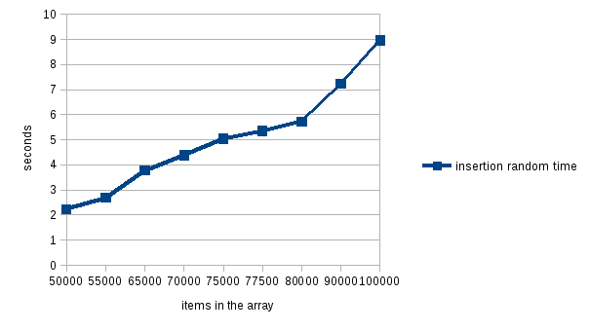

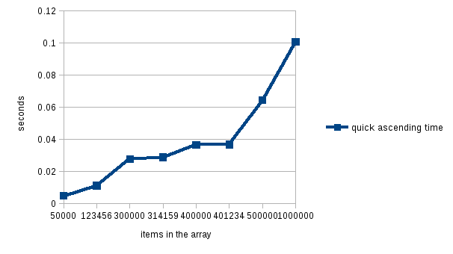
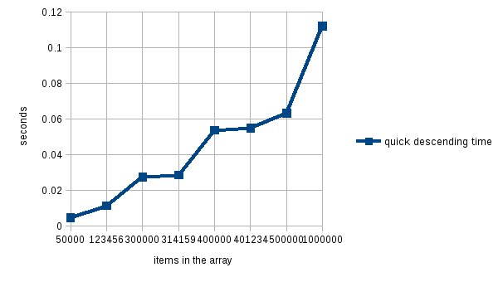
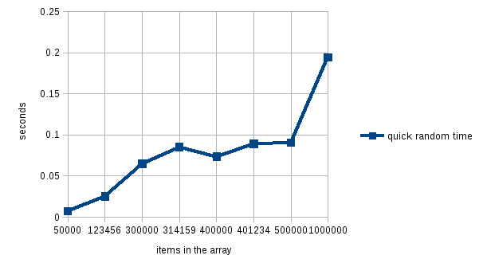

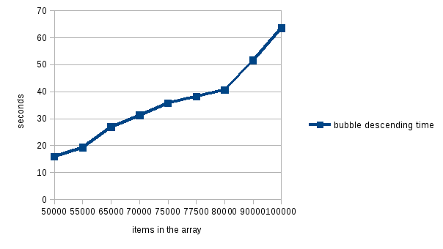
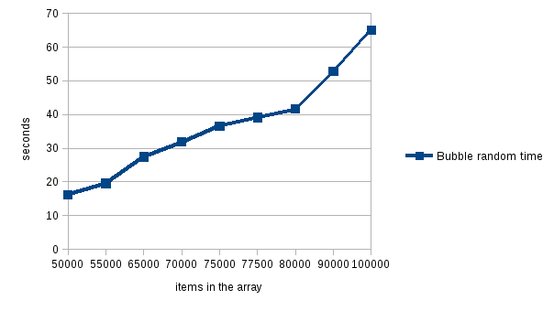
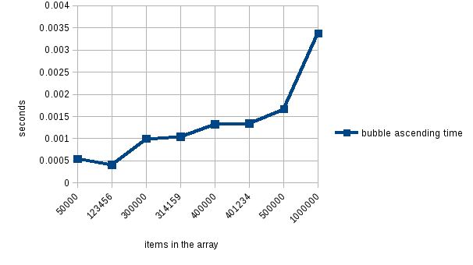

Bubble sort
A. ascending – it seems as though its a O(n) function as from 500000 items to 1000000 items the time in seconds only only increased at a factor of 2. The same can be shown for 400000 items to 1000000 items as it increases by a factor of 2.5.
B. descending- it seems as if its a O(n^2) function as from 50000 items to 100000 items it Increases by a factor of 4 even though the items were only increased by a factor of 2.
C. random - for this one its looks to be O(N^2) because from 50000 items to 100000 items it Increases by a factor of 4 even though the items were only increased by a factor of 2.
insertion sort
A. ascending - O(NlogN)
B. descending – O(n)
C. random – O(n^2)

Selection sort
A. ascending- O(n^2)
B. descending- O(n^2)
C. random- O(n^2)

Quick sort
A. ascending – O(N)
B. descending – O(N)
C. random -O(NlogN)

Merge Sort
A. ascending – O(N)
B. descending-O(N)
C. random – O(N)

10million items

Bubble sort
A. ascending – O(n) - .0337572 seconds
B. descending- O(n^2) - 635510 seconds
C. random - O(N^2) - 655510 seconds
insertion sort
A. ascending - O(NlogN) - .0337572 seconds
B. descending – O(n) - .24781 seconds
C. random – O(n^2) – 89571.1 seconds

Selection sort
A. ascending- O(n^2) – 135270 seconds
B. descending- O(n^2) – 139463 seconds
C. random- O(n^2) - 143758 seconds

Quick sort
A. ascending – O(N) – 1.00692 seconds
B. descending – O(N) – 1.12239 seconds
C. random -O(NlogN) – 1.94577 seconds

Merge Sort
A. ascending – O(N) – 1.29426 seconds
B. descending-O(N) – 1.31105 seconds
C. random – O(N) – 2.7598 seconds

